

**ACKNOWLEDGEMENT**

First, we would like to thank Allah Almighty for giving us the strength to do this project.

We would also like to express our deep gratitude to Miss Asma Rehman– our instructor for Principles of Marketing, for her patient guidance and constructive criticism on this term project.

Yours truly,

Aiman 20191-25723

Muhammad Fahad Quereshi 20191-26433

Suraksha Nihal 20192-25146

Sunny Tharwani 20181-24070

Table of Contents

**ACKNOWLEDGEMENT…………………………………………………………………………………………………………………2**

**INTRODUCTION TO MOTORBIKE INDUSTRY IN PAKISTAN……………………………………………………………5**

**Introduction To TechnoWheels……………………………………………………………………………………….6**

**MISSION……………………………………………………………………………………………………………………………………..7**

**VISION………………………………………………………………………………………………………………………………………..7**

**ORGANIZATIONAL STRUCTURE……………………………………………………………………………………………………8**

**UNIQUE SELLING PROPOSITION…………………………………………………………………………………………………..9**

**SEGMENTATION………………………………………………………………………………………………………………………….10**

**Types of Segmentation……………………………………………………………………………………………………10**

**TARGETING………………………………………………………………………………………………………………………………….11**

**POSITIONING………………………………………………………………………………………………………………………………12**

**CONSUMER PERCEPTION…………………………………………………………………………………………………………….12**

**4P'S OF MARKETING……………………………………………………………………………………………………………………13**

**Product…………………………………………………………………………………………………………………………..13**

**Three Level of Product…………………………………………………………………………………..13-14**

**Price ………………………………………………………………………………………………………………………….14-15**

**Placement……………………………………………………………………………………………………………………...15**

**Promotion………………………………………………………………………………………………………………………16**

**PRICING STRATEGY……………………………………………………………………………………………………………………..16**

**PROMOTION……………………………………………………………………………………………………………………………….17**

**PLACEMENT………………………………………………………………………………………………………………………………..18**

**SWOT ANALYSIS………………………………………………………………………………………………………………………….19**

**Strengths………………………………………………………………………………………………………………………..19**

**Weaknesses…………………………………………………………………………………………………………………...19**

**Opportunities……………………………………………………………………………………………………………......20**

**Threats……………………………………………………………………………………………………………………………20**

**PESTLE ANALYSIS…………………………………………………………………………………………………………………………21**

**Political…………………………………………………………………………………………………………………………..21**

**Economic…………………………………………………………………………………………………………………….....21**

**Social and Cultural…………………………………………………………………………………………………………..21**

**Technology……………………………………………………………………………………………………………………..21**

**Legal……………………………………………………………………………………………………………………………….22**

**Environment…………………………………………………………………………………………………………………..22**

**ACTION PLAN……………………………………………………………………………………………………………………………..23**

**CONCLUSION................................................................................................................................23**

**INTRODUCTION TO MOTORBIKE INDUSTRY IN PAKISTAN**

In the beginning years of the 21st century, nobody thought that Pakistan motorbike industry will flourish at such exorbitant scale. Use of the motorbike was not much as compared to the present. There were only two manufacturing industries in the country by name atlas Honda and Dawood Yamaha. But later as the trend of motorbike started growing steadily government of Pakistan started to welcome new manufacturing companies in the market. China started participating in the motorbike with new technology.

Following factors played a vital role in the development of the motorbike industry:

Local vendors started providing body kits of the motorbikes and engines was coming from China. China was providing new reliable equipment at a low rate with high technology.

The government started to provide loan to middle-class families as they can purchase motorbikes. People started to assemble parts in small places instead of the big industry by this they saved their high expenses. These policies started showing positive results as Pakistan motorbike industry production of units reaches nearly 2 million annually according to a report of the year 2018. Nowadays motorbike becomes the need of every person in society.

**INTRODUCTION OF TECHNOWHEELS**

Our company’s name, someone can easily get the mission of our company. Yes, our purpose for this company is to introduce new types of technologies in Pakistan Motorbike industry. Many big companies have come up with the idea of Scooty motorbike but they either couldn’t survive or were at high prices. We are manufacturing our product at a very low cost because we are making it without the gearbox system. This type of technology is beneficial for both the buyers and sellers because both sides will be equally happy with it.

The public of Pakistan, especially girls and household women need this kind of product from a very long period. So, by introducing Techno Wheels Scooty we are also helping them in reaching their destinations by themselves

On the other side, scooty consumes less fuel as compared to motorbikes and maintenance of the scooty is very easy.

We are introducing a hetch box as women can carry their thing easily like shopping bags and vegetable bags.

In the first phase of this planning, we are manufacturing the basic models of the scooty after getting a positive outcome we will move towards on the modifications like a heavy bike their body kits will be modified with the same engine range in a very cost

**MISSION**

Our mission is to provide high quality scooty with an affordable price for all types of families in Pakistan as they can ride without any gender discrimination.

**VISION**

Our vision is to provide new developments in the industry of the motorbike industry by introducing new types of vehicles. According to the current situation of roads and traffic. As in future, every household has their scooty.

**ORGANIZATIONAL STRUCTURE**

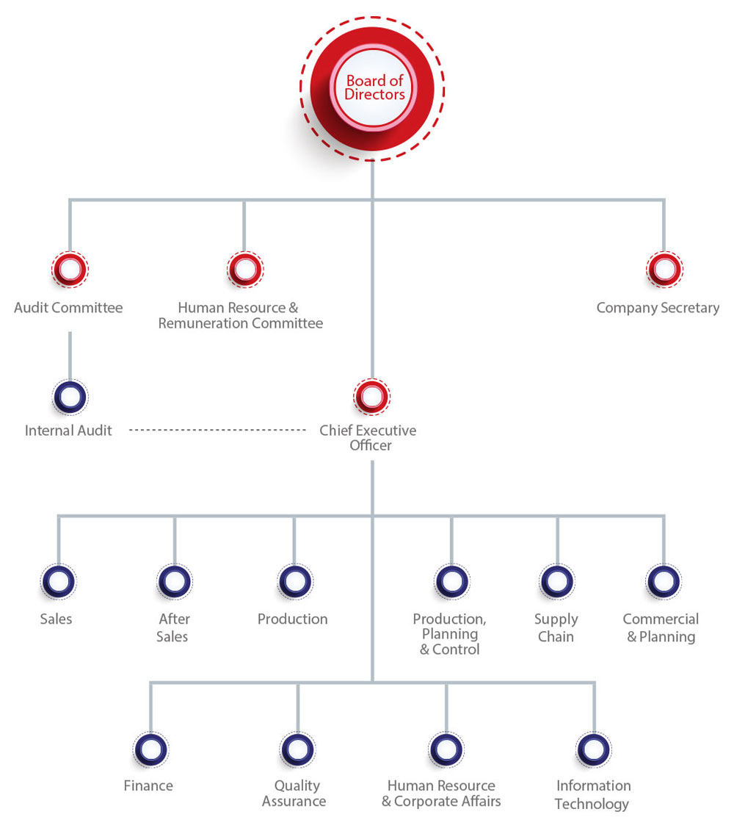

**UNIQUE SELLING PROPOSITION**

There are some of our competitors in the market but they are still unable to finding a way of increasing their market share because the people want some kind of change. The change does not mean low petrol consumption or low prices-high quality. Therefore, TechnoWheels is coming up with the no gearbox system in the Scooty. It will be very much easy for new learners, teenagers, old ones to drive it with less confusion of controls. They just have to control the breaks and accelerator.

Another aspect of no gearbox is that the manufacturing cost will be automatically cheap than the other ones. So, the customers will be able to buy it at a low price.

**SEGMENTATION**

Marketing segmentation is the practice of dividing your target audience(s) into smaller groups based on demographics, personality, common interests and much other psychographics and behavioural traits to have a better understanding of the customers.

**TYPES OF SEGMENTATION**

**DEMOGRAPHIC SEGMENTATION**

TechnoWheels has demographically segmented its market between the age bracket of 18 to 30 or above based on the interests. TechnoWheels has introduced a few categories of Scooty to cater to the wants and interests of its customers. TechnoWheels is specially introduced and manufactured to serve the females of Pakistan who want to be independent. Few women find it difficult to sit on a regular motorbike that is why TechnoWheels has come forward to cater to the needs of women of Pakistan.

**GEOGRAPHICAL SEGMENTATION**

TechnoWheels has geographically segmented its market in the urban areas of Pakistan by introducing different models in a few categories convenient for the residents in the urban areas for their daily usage.

**INCOME SEGMENTATION**

Some families cannot afford one bike for each family member. Therefore, TechnoWheels has introduced Scooty on affordable prices to cater to the need of families who cannot afford expensive bikes and other vehicles. One family can easily afford it according to their needs. If you buy a car, you will be able to carry four persons at a time under one condition that you all go to the same destination. It is also not much difficult to drive as there is no gear system. You just have to maintain breaks and accelerator to reach your destination.

**PSYCHOGRAPHIC SEGMENTATION**

Social Status: lower-middle-class/upper-middle class/elite class

Personality traits: women who are interested in riding and going out to destinations on their own

Values and Attitudes: women who are interested in breaking stereotypes and being independent.

**TARGETING**

Companies need to identify and pick their target market as soon as the process of segmentation is completed based on groups and classes. It must be kept in mind that no one strategy will work for every consumer group, which is why it is essential to devise strategies according to the chosen target market.

Techno wheel’s target group

* Peoples of all classes (Lower/Middle/Elite class)
* Female students, working women, women riders.

**Selective Targeting:**

**DESTINI X01**

Purpose to give a comfortable ride for girls studying in universities and colleges, this variant consists of a low power engine of **100CC** while other features are the same as ALPHA P101 have. While it is less expensive than the other two models, so highly affordable for university students.

**ALPHA P101**

It will provide a comfortable and quality ride to working women. Help them to cover long distances in a short time because of the high-power engine of **200CC**. Besides, it consists of a trunk that can be used for carrying items like laptops, notebooks, and files.

**THUNDRA 007**

Compatible for professional riders. It will provide a luxurious ride to its consumers, there is a huge difference in features of this model it consists power engine of **1000CC** with hydraulic brakes and much more upgraded features in it such as design, fuel tank capacity, and rims size.

**POSITIONING**

TechnoWheels believes in providing the best without compromising on its quality, keeping all the latest features in mind. The finest of parts produced in Japan are used, which are reliable and of top quality. Scooties and parts are offered only. We offer Scooties for college/university students, working women, as well as women riders. We offer services after the sale, which includes onetime free oil change and skilled labors for the maintenance of our customer’s Scooties for minimal charges as compared to outsourced mechanics. TechnoWheels follows a non-competitive pricing strategy and prices are lined independently as there is no competitor of TechnoWheels in Pakistan. Customers with higher as well as lower purchasing power both are our target, and for them, we have introduced three models DESTINI X01(For College/university students), ALPHA P101 (For working women) and THUNDRA 007 (Women Riders). TechnoWheels stands on the low price high-quality segment in the positioning map.

**CONSUMER PERCEPTION**

The world is finally recognizing the needs of women, and taking forward this approach Technowheels has decided to launch scooters exclusively for women. The trend of using scooters nowadays is a key to support consumer daily movement.

Technowheels has introduced scooters with no gear system, to make drives easy for women. This is a first as no other brand has launched anything specifically for women, this will help our target market remember the brand. Moreover, the general public might also appreciate this thoughtful initiative.

**4P’s MARKETING MODEL**

The **4P's** of Marketing – Product, Price, Promotion, and Place– are key marketing elements used to position a business strategically.

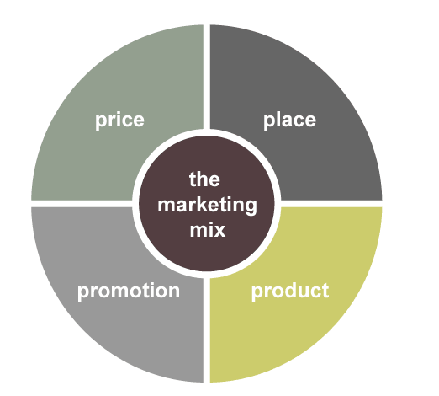**PRODUCT**

**Three Levels of Product**

**Core Benefit**

There will be different categories which we will target; women market of motorbikes. We will ensure to provide the best quality products. We will introduce models with new and different designs each year. Moreover, we will be introducing 300hp scooties which will be a great success for us because it will be the one of its kind, our research team have a plan for it but will start working on this mega project after observing the public response towards TechnoWheels. Some of the details are:

300hp motorbike converts the perception that women’s can’t ride motorbikes, this model offers a hybrid engine with a battery backup of 30-40 KM at speed of 130km/hr, making it ideal for long routes/trips.

We will use open-cell polyurethane foams in making of seats top cushioning layer, this will contribute to making a ride more comfortable.

will use top quality material as Harley Davidson used.

**Actual Product**

We will be hiring new designers so we could bring innovation and creativity. We will be test marketing our product before commercialization.

**Augmented Product**

We will be building e-commerce store which will benefit us as most customers prefer online shopping, providing 14 days refund and exchange policy to maintain customer’s loyalty, it’s so challenging for us as in motorbikes business to satisfy our customers before buying our product so for that purpose we will provide the facility of a test drive at your doorstep but for that, you have to first book an appointment from our website.

**PRICE**

Pricing of Technowheels will be based on the Standardized level of Quality. The engine power will set the price of that model. Secondly, the designs made and the rims used in that fabric will be fully evaluated. Moreover, the pricing strategy of 300hp motorbikes would be premium pricing. Following are the types of pricing strategies that we plan to implement at Technowheels:

**Cost-Plus Pricing**

Cost-plus pricing is the simplest pricing method. The firm calculates the cost of producing the product and adds on a percentage (profit) to that price to give the selling price.

**Market-Oriented Pricing**

It also uses Market Oriented pricing i.e. setting a price based upon analysis and research compiled from the target market. This means that marketers will set prices depending on the results from the researches and survey it has conducted.

**Value-Added Pricing**

"Value-added" means adding superior value to a product to gain customer satisfaction. Value-added pricing is a pricing strategy that attaches value-added features and services to differentiate a market offering and support higher prices, rather than cutting prices to match competitors. To increase their pricing power, many companies adopt this strategy. Technowheels will aim to provide an additional feature of value to all its products, this factor helps to make its customers loyal to the brand.

**Market Skimming and Market Penetration**

TechnoWheels will use the Market skimming strategy rather than market penetration, as we are the sole company establishing a plant for scooties in Pakistan.

**PLACEMENT**

We will be launching our brand in Pakistan and opening up outlets across Karachi. Our main target will be the local market; selling through stores and online. We’ll be using the vertical marketing system as shown in the figure.

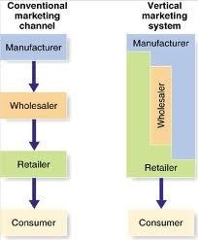Placement Strategies:

1. Setting channels for distribution

2. Cost of physical distribution

3. Transportation and warehouse

4. Salesforce

**PROMOTION**

**Advertising**

Advertising on all kinds of media, i.e. TV, print media, billboards and online marketing, which will be our main focus, targeting through different social media platforms such as Facebook, Instagram etc. We will also be doing influential marketing by featuring celebrities, bloggers, makeup artists which will help to increase our sales also this strategy will help Technowheels in encouraging women to use scooties for there convenience purpose

**Sales Promotion**

Offering new year sales, Eid sales, Independence Day Sales to our customers.

**PRICING STRATEGY**

As we are starting a new kind of product in a market, where this product is already available with few changes. But the product has not been able to get much attraction because of huge prices and less awareness also. We will be talking about the awareness portion in a later paragraph. But here we are considering the first and the most important point and that is the price factor. As we have already discussed that, we have manufactured our problem without gear system and this makes it easy to reduce the cost price. So, therefore we will be able to offer our product at the price that will be very much low from the market competitors. According to our research, an average gearbox costs 5000 per bike and it ends up to almost 5500 after adding all the mechanical and other charges. By doing this calculation, our product will be at least 5000 cheaper than the others.

After all this, we will try our best to give suitable discounts to the customers. For example, we will sell our product to the whole sellers at a 5% discount rate, so that they can give at least 3% discounts to the retailers. And finally, the product can easily reach to the customer at the factory price without any kind of charges. At the final purchasing stage, the customer will be able to get free first-time maintenance like free mobile oil change, free Scooty wash and other.

**PROMOTION**

In the current time, almost everyone is connected to social media platforms such as Facebook, Instagram, YouTube, and Snapchat. These social media platforms have now become the biggest source of marketing around the globe. So, we have an IT team which is specially hired for digital marketing of our product. The team will make sure that everyone using social media must see our product advertisement once a day. On the second, people always search for something like, ‘best scooty in Pakistan’. So, we will contact the bloggers and top websites to name our product on the list of the top 10.

Our promotion includes a college/university campaign. In this campaign, we are going to some of the famous universities and colleges in Pakistan where we will arrange a seminar for our product. The students will be asked to make a trial of new product and give feedback over it. We will offer a direct 5% discount for university students. So, they get more interested in our product.

We will hire some of the university students who can directly collect orders from the students and forward them to us. The customer never hesitates in buying anything that he/she wants if the product is being sold by their relatives, friends and colleagues. Here, the students will also not feel confused if their friends offer them discounts and directly supply them. For more promotions on TV, we will approach to female celebrities. You have seen that when any motorbike or car advertisement appears, the role is always played by any male celebrity. In our promotional advertisement, a female will appear in ad driving a Scooty with less confusion and telling about the functions. She will probably play the role of a household mother who is going to drop her child to the school herself on Scooty.

**PLACEMENT**

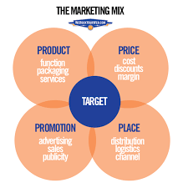People mostly focus on showrooms for these kinds of products. So, we have a separate showroom of Technowheels. We will also make it available at different supermarkets like a hyper star and others. People will also be able to make an online order for our product. We will make delivery of it across all Pakistan. Going to rural areas, we will sell this product to the distributors there because online shopping is not that much popular there as per now.

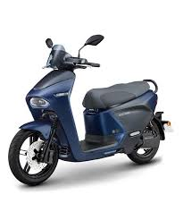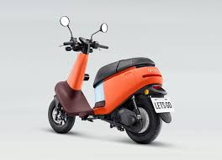

**SWOT ANALYSIS**

**STRENGTHS**

**Market Need-Based Product:**

Technowheels is offering a product that has become a need for various households nowadays. Although, it is being offered already we have made some changes in it.

**Non-Active Competitors:**

There are some of our competitors in the market who are already making this kind of product but they are not making any change in it. It is just like same as a regular motorbike except for their seating arrangements. This is the reason that they are unable to grow the market share until now.

**Low Cost:**

As mentioned above, our product is already cheap at its manufacturing stage, so therefore we will be able to sell it a low price as possible.

**WEAKNESSES**

**Product Penetration**

Here we are doing some type of product penetration because we are entering an existing market with a new product and that is risky because there is a chance that our product cannot survive.

**High Promotional Expenses:**

Due to the new product, we have to spend a lot over advertisements and promotions. If we do not do this, it will be hard to convey our message to the targeted audience.

**OPPORTUNITY**

**Less Competition:**

As we have no big competitor in the market, so we have an opportunity to make the audience attracted to our product. People want this kind of product, so are fulfilling their demand. This will make us loyal towards our new audience.

**THREATS**

**Easy Manufacturing:**

The manufacturing of Technowheels is so easy that it can be easily copied by other manufactures. They just have to make a bicycle with an engine in the shape of Scooty. There will be no additional cost charges for them because they already have a built-in market and factories. We consider it as the biggest threat for us.

**PESTLE ANALYSIS**

**POLITICAL**

The threat would be imposed on TechnoWheels if there is political instability. Companies or organizations usually face a decrease in sales due to political instability. TechnoWheels will also eventually face a decrease in sales because the raw materials are imported.

**ECONOMIC**

A change is economic conditions will either increase or decrease the sales of the company. A negative change in the economic conditions will lead to increase in unemployment, increase in the rate of inflation, decrease in quantity demanded, and eventually less income due to which the purchasing power will not be strong of the company. This would not only affect the sales of TechnoWheels but also the overall profit margin due to the negative changes in the economy. However, if there is a positive change in economic condition then it will lead to strong purchasing power.

**SOCIAL AND CULTURAL**

Changes in social and cultural will eventually lead to changes in sales and profit margin of TechnoWheels. For instance, because of breaking stereotypes awareness and campaigns, women are coming out of their comfort zone and having a taste of independence and TechnoWheels is trying to make the road slightly less bumpy for the women of Pakistan.

**TECHNOLOGY**

Advances in technology in the Pakistani market will lead to increase sales of TechnoWheels of women are willing and interested in driving scooty around to get the chores done or simply reaching to their destinations by themselves and want to be independent.

**LEGAL**

Any change in legal policies could affect TechnoWheels as a brand. For instance, if there is a change in legal policy about import then it would affect TechnoWheels because the company imports all the raw materials and it would affect the brand’s sales and profit.

**ENVIRONMENT**

Changes in environment policies may not affect TechnoWheels overall as a brand because TechnoWheels manufactures its scooties which does minimum damage to the environment by polluting less. After all, the company cares about the environment and climate of the country and as of the whole planet.

**ACTION PLAN**

TechnoWheels have a different action plan for each of its product or model. Mostly it depends on the product or model in this case when it is launched and if that is what people want or feel the need to have.

TechnoWheels believes that if the launch of THUNDRA 007 for women racers in Pakistan and it does not work then we will change the features and modifications then change the target audience from women to men. Although, women are trying to come out of their comfort zone to break the stereotypes sometimes immense change can be exhausting. So, we will change the target audience with some more modifications and new features will be included so that male racers can be able to use.

**CONCLUSION**

In conclusion, TechnoWheels marketing strategy is based on the needs of customers and social awareness of the country. TechnoWheels main aim is to make chores and work easier for the women of Pakistan based on their needs and interests.

The second aim is to pollute our environment less due to this TechnoWheels manufactures scooty which pollutes the environment or climate slightly less than the others. TechnoWheels strategy is based on the marketing conditions of Pakistan.